**Mild to Moderate evaluation**

Sample_ID: **Y68K4H(CAT)**

Link: <https://release.animalbiome.com/pet/assessment/report/b09ff653-5e5b-4b16-ab6c-83b14883554d>

Mild to Moderate

Cats and dogs:

Any Two

(High Yellow Flag Megamonas OR (failed)

High Yellow Flag Sutterella OR (failed)

High Yellow Flag Collinsella OR (**passed**)

Low Yellow Flag Bacteroides OR (failed)

Low Yellow Flag Blautia (failed)

)

OR

Cats: 8-10 Yellow Flags: 6 (failed)

OR 5-8 Red Flags: 1 (failed)

OR diet recommendation of increase fiber (failed)

OR diet recommendation of increase protein (**passed**)

(any of: low red flag Bacteroides, high red flag Fusobacteria, high red flag Collinsella, high red flag Sutterella, **low red flag Fusobacteria**, high red flag Prevotella) (**passed**)

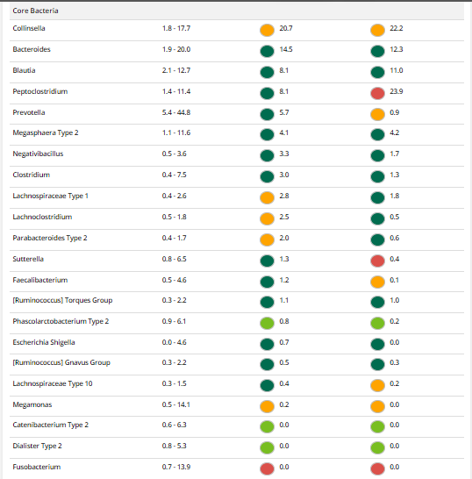

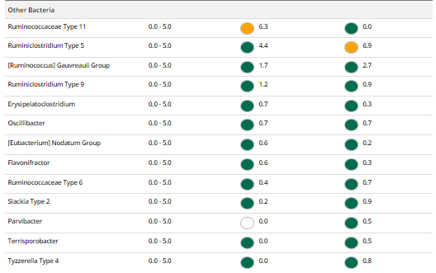

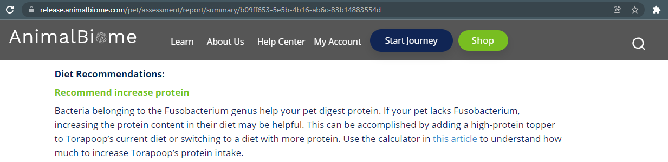

The result: **False False False True**

Expected result: Mild to Moderate

Achieved result: passed

